Input file cprog.c for simple lexicalanalyser program:

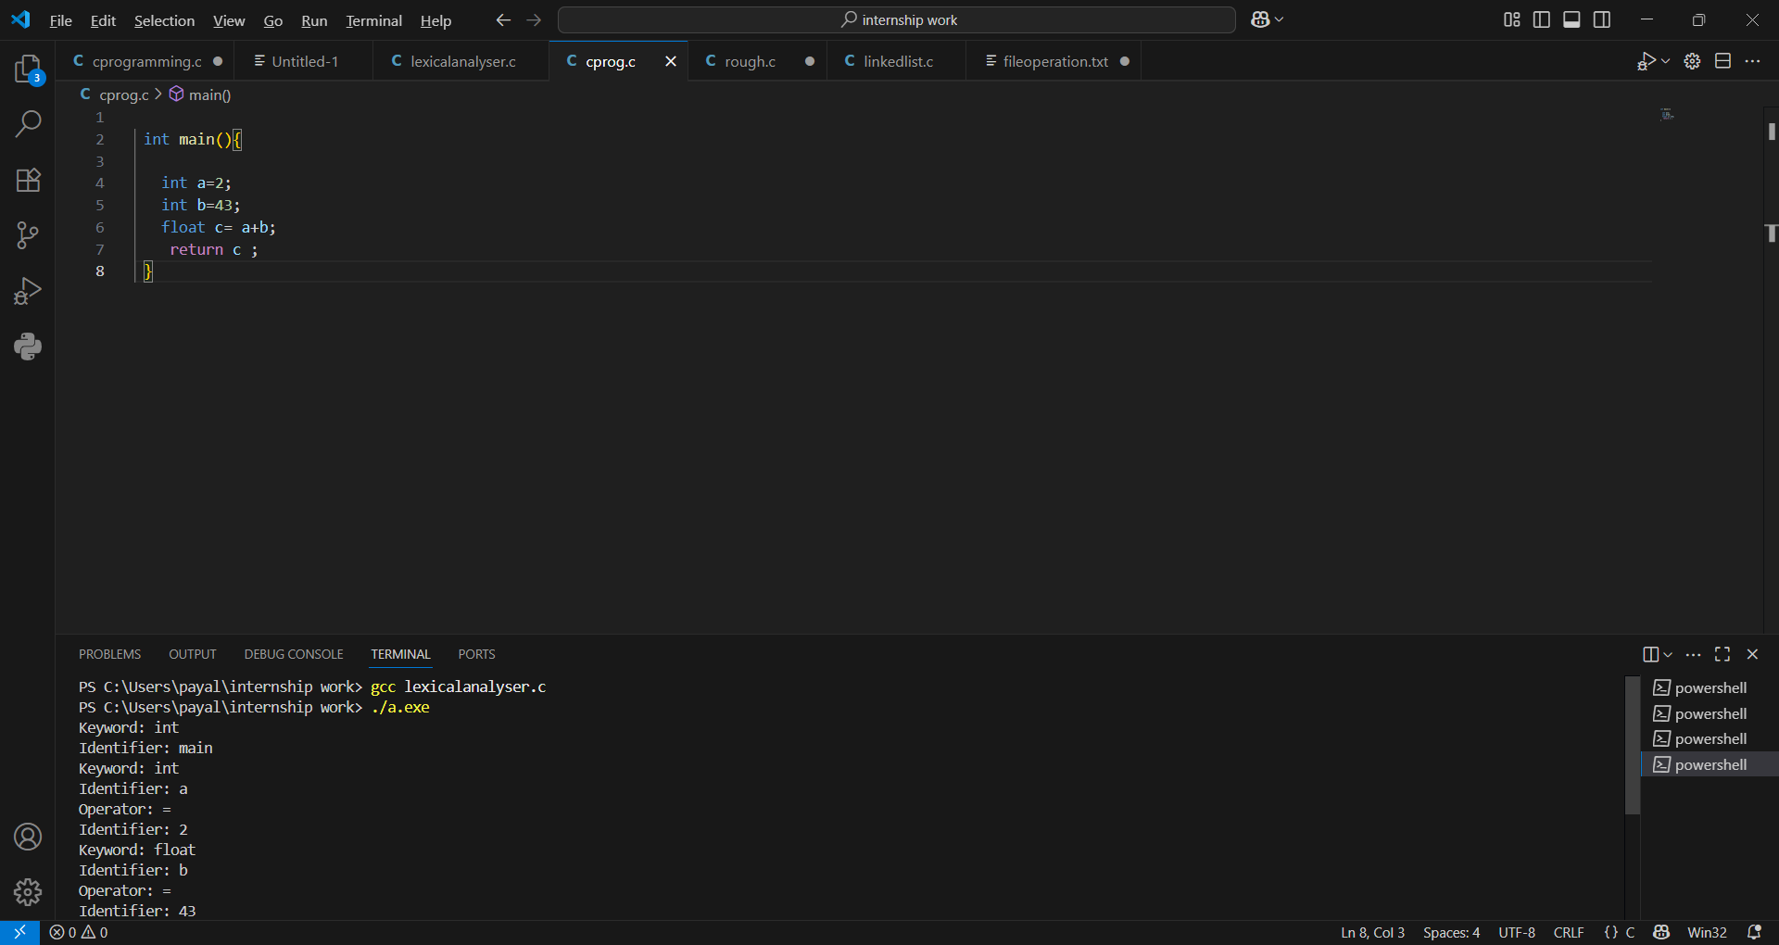

OUTPUT:

